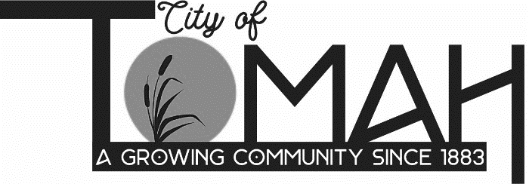

07/07/2026
PUBLIC NOTICE

Operation Phoenix Downtown Revitalization
Tuesday, July 7, 2026, at 6 p.m.
Recreation Station, 316 Arthur Street, Tomah, WI.

On the above dates and times, it is possible that a quorum of members of other governmental bodies of the municipality may be in attendance at the above – stated event to gather for a community event. No action will be taken by any governmental body at the above state meeting.

This notice is posted according to Wisconsin Open Meetings Law Wisconsin State Statues, Section 19.81 – 19.98

