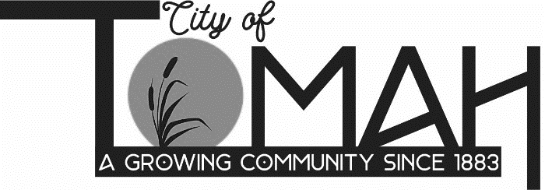

07/30/2026
PUBLIC NOTICE

City-Owned Building Tour
Monday, August 3, 2026, at 5:30 p.m.
1007 & 1009 Superior Ave, Tomah, WI.

On the above date and time, it is possible that a quorum of members of other governmental bodies of the municipality may be in attendance at the above stated gathering. No action will be taken by any governmental body at the above-mentioned meeting.

This notice is posted according to Wisconsin Open Meetings Law Wisconsin State Statues, Section 19.81 – 19.98

