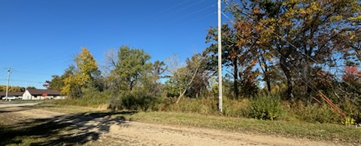
City of Tomah, Wisconsin

Jefferson Street Property Residential Development

REQUEST FOR PROPOSALS (RFP)

Issued: September 1, 2026
Due: October 15, 2026 / 4:00pm

City Contacts:
Charlie Handy, Zoning Administrator
819 Superior Avenue | Tomah, WI 54660
chandy@tomahwi.gov
Photo by: Bob Johnston

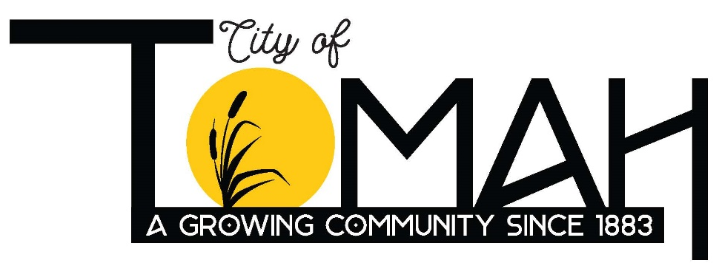
Photo by: Doug Richter
Photo by: Maura Konzen
Photo by: Ryan Ebert

City Snapshot
  - Tomah Market
- Location: The City of Tomah is located in west central Wisconsin, within Monroe County, along the Interstate Highway 90/94 corridor. Tomah has a population of approximately 9,572 (Wis. DOA 2026 estimate) and offers a wide range of amenities with the ability to meet most daily needs. Tomah is only a 45-minute drive from La Crosse and the Wisconsin Dells and located at the crossroads of Interstates 90 and 94, providing superior accessibility to the north, west, and central parts of the state.
- Schools: The Tomah District enrolls over 3,056 students. The district’s student to teacher ratio is comparable to similar districts and the entire state. Additionally, there also are multiple private school options and a Western Technical College satellite campus in the City.
- Job Market: There are several large employers in Tomah including the V&A Medical Center, Walmart Distribution Center, Toro Company, Cardinal Glass Industries, and Tomah Health. Additionally, the City offers great accessibility to large employment markets in La Crosse, Fort McCoy Military Base, and Camp Douglas National Guard Base for hybrid office/remote workers or commuters. The city is heavily influenced by the Federal installations. It is home to the Veterans Administration campus. It is also within 7 minutes of the main gate of Fort McCoy and 17 minutes of the main gate of Volk Field.
- Social and Recreation Amenities: There are plentiful recreational opportunities in Tomah including year-round community festivals, exceptional parks system (12 parks covering 251 acres), public art installations, downtown shopping and entertainment, regional shopping destinations, a 280-acre lake, and more.
- Healthcare: Tomah Health provides a full range of health services including general care, hospice, imaging, infusion, occupational health, rehabilitation, surgery, and several specialists. Gunderson Health also has a clinic in the City. In addition, the V&A Medical Center provides addiction care, cardiology, dermatology, diabetic care, mental health care, neurology services, and several others. The center employs nearly 1,400 people and serves more than 58,786 veterans in 16 counties in Wisconsin and Minnesota.
- Housing Demand: Tomah needs an estimated 400 to 700 new homes by 2030 to house the people its economy is already attracting, against a build rate near 36 a year over the 2010s that has slowed to about 29 a year since. Employers watch qualified workers turn down jobs, or commute in from La Crosse and Onalaska, because they cannot find or afford a home in town. Like much of the country, Tomah is short on housing. Unlike much of the country, it has quantified the gap, named the price points the market wants, and lined up public tools to help close it. This is the city’s most pressing need and its best-documented opportunity.

For more information, please visit the City’s website and its marketing plan: https://www.tomahwi.gov/buildingzoning/page/economic-development:

The Opportunity
  - Purpose of RFP and Objectives
The City of Tomah is seeking statements of interest, evidence of capacity, and proposals from qualified developers and/or builders to construct a residential project on a city-owned 4-acre greenfield parcel. Objectives for the project include:
- Two-family or smaller scale multi-family residential development consistent with surrounding residential uses.
- Partnering with a developer and/or builder to plan and construct a project.
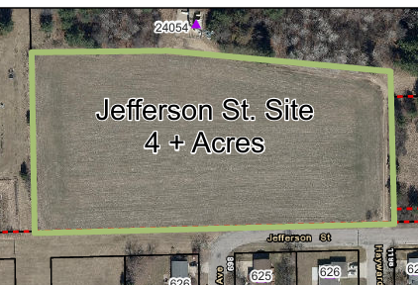
The subject site is located north of Jefferson Street, near the intersection of Jefferson Street and Schneider Avenue. The development area is currently part of a large parcel (parcel number 020-01216-0000) within the Town of La Grange (49-acres). The City is currently in the process of completing a CSM to create the 4-acre development area, acquire the development area (closing date set for September 1, 2026), and annex the land into the City of Tomah (anticipated to be completed by September 30, 2026).
South of the site, on the south side of Jefferson Street, is a mixed residential area of existing single-family, two-family, and vacant platted lots. Neighboring properties to the west are in the Town of La Grange and properties to the east are in the City of Tomah. The site is located less than a mile from Lake Tomah, the Tomah multi-use trail, downtown Tomah that includes restaurants, taverns, and retail shopping.
The City-owned property is currently being rezoned to R-3 Residential with the intent to “accommodate residential uses for citywide and regional benefit.” See here for a full list of permitted uses, permitted accessory uses, and conditional uses. The City recently amended the Zoning Ordinance’s bulk standards for setbacks, lot sizes, and lot coverage and the online code has not yet been updated. The amended version is provided below within the appendix.
The City of Tomah Comprehensive Plan identifies the future land use of this site as Planned Neighborhood, providing the ability to rezone to any type of residential district without an amendment.
The subject property is also immediately adjacent to public utilities and street improvements within Jefferson Street that can be extended into the site.
Finally, the development site is not currently located within a Tax Increment Financing District.

RFP Submittal Requirements
Submittal Contents
Interested parties should submit the following information organized in the order shown below with a maximum of 10 pages not including section dividers (if provided) and appendices. Note that weblinks in lieu of appendices are acceptable and encouraged.
Cover: Include project name, respondent name, and date.
Section 1 Cover Letter: Introductory cover letter identifying the lead entity, contact information for the proposed project manager, and a statement that the respondent has reviewed this RFP including a list of all specific addendums that the City may subsequently issue (1 page max).
Section 2 Development Team Organization: Overview of the development team organization indicating the lead entity and lead individual for each component of the work (1 page max). Include resumes for the key project team members (1 page max per individual) in an appendix.
Section 3 Summary of Experience: Feature the development team’s skills and relevant experience applicable to this site. Include brief descriptions of at least three specific projects and list municipal references for each (3 pages max). More detailed project descriptions may be provided in an appendix.
Section 4 Financial Relationships: Provide contact information for banking and other financial entities that have participated in past projects (1 page max).
Section 5 General Project Approach Summary: Include a brief narrative summary and potential development concepts (3 pages max) expressing your team’s:
- Project understanding and interest
- Project approach and potential development ideas for the site (note that drawings and project details are not required but can be attached as an appendix if desired)
- Approach to working with the City to craft and execute a development plan and negotiate a developers agreement
- Tentative project schedule
Format, Transmittal, and Questions
The entire submittal including all appendices must be provided in a single PDF file and delivered to the City no later than 4:00 pm, October 15, 2026. Transmit the file, or a link to it, electronically to the following address. Please use the subject line “Jefferson Street RFP Submittal.”
Charlie Handy, Zoning Administrator
819 Superior Ave. Tomah, WI 54660
Email: chandy@tomahwi.gov
Questions about the contents of this RFP can be submitted via email to the above address or by phone to (608) 374-7511 by 4:00 pm, Sept. 15, 2026. All questions will be recorded and responses posted to the City’s webpage by September 19, 2026. Questions and inquiries submitted after Sept. 15, 2026, will not be answered.

RFP Selection Process
Evaluation of Qualifications
The City will create a Project Team consisting of members from the Planning Commission and City staff to evaluate all submittals, conduct interviews, and recommend a preferred developer to the full City Council.
The City will use a “Qualifications Based Selection Process” to review and rank the written proposals based on the following:
RFP Evaluation Criteria
The following RFP evaluation criteria will be used to select the short list of development teams that will be invited to move on to the Developer Review stage of the selection process for the Site.
- The respondent’s agreement to abide by the minimum business terms identified in this RFP.
- Development of projects of a similar scope and scale.
- Financial capacity to undertake a project of the proposed magnitude.
- Overall quality of the development team.
- Experience with similar public/private development agreements with public sector entities.
- Quality and completeness of the RFP response.
- Quality and feasibility of the proposed project, and overall fit within the neighboring area
- Provision of Affordability within the project
Based on the above, the Project Team will invite no more than three of the top-ranked development teams for an interview. The interviewed teams will then be evaluated using the criteria listed above in addition to any other information requested at the time of the interview.
Project Schedule
The following contains a tentative schedule the City intends to follow in identifying qualified developers, soliciting proposals from them, and negotiating terms with them. The City reserves the right to alter this schedule at any time, with or without prior notice, and will post any changes on its website.

Task | Timing
RFP Issued | September 1, 2026
Questions on RFP Due | September 15, 2026
Answers to Question | September 19, 2026
RFP Response Deadline | October 15, 2026
Interviews | October 17, 2026
City Council Evaluation | October 19, 2026
Negotiate Developers Agreement | October 19, 2026 – November 19, 2026
Construction Begins | Spring 2027

Disclaimers
Property Conditions: The descriptions of the conditions of the property contained herein are generalized depictions. The City does not represent or warrant the accuracy of any of the information, and no party should rely on such information.
All Costs on Respondent: Respondents shall be responsible for any and all costs they incur in responding to this RFP.
Submittals Subject to Open Records: All responses to this RFP shall become property of the City of Tomah and are subject to the Open Records laws of the State of Wisconsin. Any information a respondent deems to be proprietary or trade secrets should be specifically identified as such, but the City cannot guarantee that such information will remain confidential if required to be disclosed under Wisconsin law.
Schedule Subject to Change: The City will use good faith efforts to adhere to the schedule described herein but reserves the right to modify the schedule at any time and without prior notice where it is in its best interest to do so. Any changes will be posted to the project webpage.
Right Reject All: The City reserves the right to reject all proposals and not proceed with the project if deems it in its best interest to do so.

Helpful Links
2022 Tomah Housing Assessment: https://www.tomahwi.gov/sites/default/files/fileattachments/economic_development/page/4247/city_of_tomah_housing_assessment_-_october_2022.pdf
City of Tomah Comprehensive Plan: https://www.tomahwi.gov/sites/default/files/fileattachments/economic_development/page/4247/2024_city_of_tomah_comp_plan_7.16.24.pdf
Tomah Zoning Code: https://library.municode.com/wi/tomah/codes/code_of_ordinances?nodeId=COOR_CH52ZO
Tomah Subdivision Code: https://library.municode.com/wi/tomah/codes/code_of_ordinances?nodeId=COOR_CH40SU

Appendix
Sec. 52-40. Schedule of Regulations
Following is the schedule of regulations as they apply to each zoning district.
Zone | Lot  Requirements |  | Minimum Yard Requirements (Ft.) |  |  |  |  |  | Maximum  Building Height |  | % Max. Lot Coverage | Min. Lot Area Per Dwelling | Use
Zone |  |  | Principal Buildings |  |  | Accessory Buildings
Zone | Area in Sq. Ft. | Frontage in Ft. | Front | Each Side  (a) | Rear | Front | Each Side (a) | Rear | Stories | Feet | % Max. Lot Coverage | Min. Lot Area Per Dwelling | Use
R-1 Residential | 6,000 | 40 | 20 (g) | 8 | 20 | (b) | 3 | 3 (f) | 2 | 35 | 60 | 6,000 | 1-family dwelling
R-2 Residential | 7,200 | 60 | 25 (g) | 10 (h) | 30 | (b) | 3 | 3 (f) | 2 | 35 | 40 | 3,600 | 2-family dwelling
R-3 Residential | 7,200 | 60 | 25 (g) | 10 (h) | 20 | (b) | 3 | 3 (f) | 3 | 40 | 60 | 1,800 | Multi-family dwelling
R-4 Residential | 7,200 | 60 | 25 (g) | 10 | 30 | (b) | 3 | 3 (f) | 2 | 30 | 30 | 7,200 | Manufactured dwelling
R-5 Residential | (j) |  |  |  |  |  |  |  |  |  |  |  | Manufactured dwelling park
- On a corner lot where the parcel has multiple street frontages, the corner side yard shall meet the minimum side yard setbacks as listed for each district.
- The minimum front yard setback for all accessory structures shall be even with or behind the on-site principal structure’s front yard setback. An accessory structure shall not project further towards the street than the principal structure.
- Minimum side or rear yard when abutting a residential district is 15 feet.
- Minimum side or rear yard when abutting a residential district must be 50 feet.
- Minimum side or rear yard when abutting a residential district must be 100 feet.
- Accessory buildings must be placed in the rear yard or conform to the yard requirements of a principal building.
- Front yards. On every lot in a residential district, and every existing residence in the business district, there shall be a front yard having a depth of not less than 20 feet.
- Zero feet on side of common wall with adjacent structure. Opposite interior side-yard setback shall be a minimum of eight feet.
- All structures exceeding three floor levels or a height above grade of 45 feet shall require approval from the City of Tomah Fire Department.
- Minimum of 10 acres in area.

