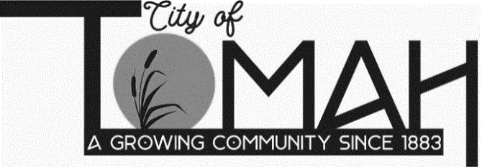
819 Superior Ave
Tomah, WI 54660
Phone: (608) 374-7420
Fax: (608) 374-7424

AGENDA FOR HISTORIC PRESERVATION COMMISSION

MEETING NOTICE

A Tomah Historic Preservation Commission Meeting will be held on
Thursday, June 9, 2022 at 5:45 p.m. in the Municipal Center Council Chambers,
819 Superior Avenue, Tomah, WI 54660.

AGENDA

- Call to order & roll call
- Approval of May 12, 2022 minutes
- Michianza Days
- Flea vendors
- Wizards of Rods
- Vendors forms update
- Misc.
- Downtown Thursday Nights 50/50
- Funds
- Direction
- Adjournment

NOTICE: It is possible that a quorum of members of other governmental bodies of the municipality may be in attendance at the above-stated meeting to gather information. No action will be taken by any governmental body at the above-stated meeting other than the governmental body specifically referred to above in this notice. Please note that, upon reasonable notice, efforts will be made to accommodate the needs of disabled individuals through appropriate aids and services. For additional information or to request this service, contact Becki Weyer, City Clerk, at 819 Superior Avenue, Tomah, WI 54660.

