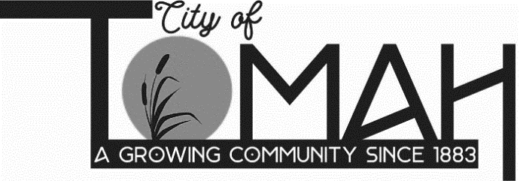

**Agenda FOR** **Historic Preservation Commission**

A Historic Preservation Commission meeting will be held on **Thursday, April 13, 2023**

**at** **5:45 PM**in the **Council Chambers at City Hall, 819 Superior Avenue, Tomah, WI.**

**AGENDA**

A. Call to order - Roll Call

B. Review and discuss Historical Preservation Standards - La Crosse Historical application

C. Discussion on developing Certificate of Appropriateness

D. Review process for designating properties and/or districts as historical - local designation on current state/federal properties

E. Review and discuss mission statement

F. Discussion of Michianza Days fundraiser

**ADJOURNMENT**

**NOTICE**: It is possible that a quorum of members of other governmental bodies of the municipality may be in attendance at the above-stated meeting to gather information. No action will be taken by any governmental body at the above-stated meeting other than the governmental body specifically referred to above in this notice. Please note that, upon reasonable notice, efforts will be made to accommodate the needs of disabled individuals through appropriate aids and services. For additional information or to request this service, contact Becki Weyer, City Clerk, at 819 Superior Avenue, Tomah, WI 54660.