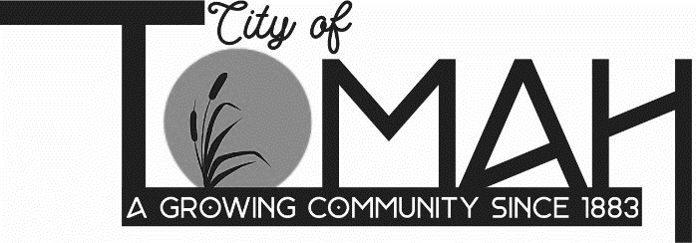

**Agenda FOR** **Historic Preservation Commission**

A Historic Preservation Commission meeting will be held on **Thursday, September 11, 2025 at** **5:30 PM**in **Room 206 at City Hall, 819 Superior Avenue, Tomah, WI.**

**AGENDA**

A. Call to Order - Roll Call

B. City Administrator Monthly Update

C. Future Agenda Items

**ADJOURNMENT**

**NOTICE**: It is possible that a quorum of members of other governmental bodies of the municipality may be in attendance at the above-stated meeting to gather information. No action will be taken by any governmental body at the above-stated meeting other than the governmental body specifically referred to above in this notice. Please note that, upon reasonable notice, efforts will be made to accommodate the needs of disabled individuals through appropriate aids and services. For additional information or to request this service, contact Nicole Jacobs, City Clerk, at 819 Superior Avenue, Tomah, WI 54660.