Junk Vehicles - One man’s junk is another man’s treasure
I believe we have all heard the term “junk vehicles” but do we really know what that means? An old broken-down disassembled car can be a treasure to some people while some people might see this same car as an eyesore that attracts mice and brings down property values. Because people can view the condition of cars and motor vehicles differently, many jurisdictions have an ordinance that regulates and defines junk vehicles. So what is a junk vehicle?
What is it?
Junk Vehicles are considered a public nuisance because they are more than just an eyesore. They have an adverse effect upon the neighbors and city property values, health, safety and general welfare. Some of the adverse effects are as follows:
- They usually are, but not always, disassembled, inoperable, damaged, rusting, and unlicensed.
- The junk vehicle can be hazardous to children and often have sharp edges, broken glass, are up on unsteady jacks, and attract mice and vermin.
- They can be an eyesore as they are often stored in the open where they are easily viewed.
- They can be hazardous to the environment as they can contain toxic fluids that may leak into the ground.
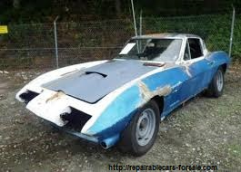  Is this a Junk vehicle or a treasure? | 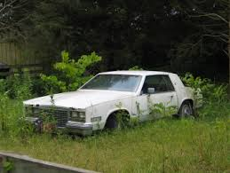  Is it operational and licensed?

The City of Tomah Code of Ordinance under Chapter 18, Article III, prohibits accumulating, storing or allowing any disassembled, inoperable, junked or wrecked motor vehicles, truck bodies, tractors, or any unlicensed motor vehicle, truck body or tractor in the open upon any public or private property in the city.
What it isn’t
When can a junk vehicle not be in violation of the City of Tomah Code of Ordinances? There are exceptions to Chapter 18, Article III. These exceptions include vehicles that are stored within a building in a lawful manner where it is not visible from the street or other public or private property; or stored or parked in a permitted manner on private property in connection with a vehicle repair or sales business.
Notices, Abatement, and Fines
Any person found to be in violation of Chapter 18, Article III, they will receive a written violation notice stating the violation, how to correct the violation, and is given 15 days to abate the violation. If the junk vehicle is not taken care of or abated, the city may cause the same to be abated, charging the costs thereof to the person in a court action for debt or in the alternative, the city may proceed with the issuance of a citation.
The current fine for the first offense is $187.00, second offense within 1 year is $376.00, and third and subsequent offences within 1 year is $510.00. For continuing violations, each violation and each day a violation continues or occurs shall constitute a separate offense.

