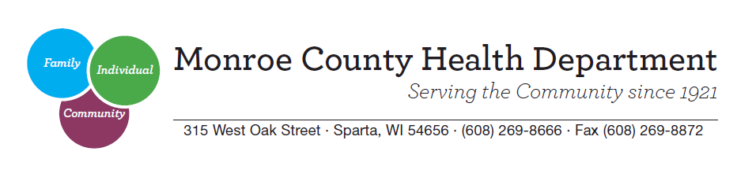

DATE: September 15, 2017

TO: Monroe County News Agencies

FROM: Monroe County Car Seat Coalition

RE: For Immediate Release. Thank you!

September 18-24, 2017 is National Child Passenger Safety Week. As you probably know, car seats, booster seats and seat belts are the law in Wisconsin. Surprisingly, only 1 in 10 car seats is used correctly. Car seat information is easy to find, but often it’s hard for parents and caregivers to decide which seat is best for their child. This resource can help to answer common questions about transporting children safely.
What is required?
The Wisconsin child passenger safety law states the minimum required. Most pediatricians and injury prevention professionals recommend more than the minimum to protect children in a crash. This is called “best practice.”

Type of seat | Wisconsin law | Best practice
Rear-facing car seat | Children must be rear-facing in a car seat until age 1 and 20 pounds. | American Academy of Pediatrics recommends children stay rear-facing until at least age 2 or longer if they are still within the weight and height restrictions of their rear-facing seat.
Forward-facing  harness seat | Once a child is in a forward-facing car seat, he or she must remain in a harness until age 4 and 40 pounds. | Some seats have harness weights up to 50-80 lbs., allowing children to stay in a harness longer. Children are much better protected when restrained in a harness.
Booster seat | A booster seat is required once a child has graduated from a forward-facing harness seat, until the child reaches one of the following: 8 years old or 80 pounds or 4 feet and 9 inches tall. | Children should stay in a booster seat until they are tall enough to sit on the vehicle seat without slouching and the seat belt fits snugly across the hips, chest and shoulder. This is usually 4’9”.
Seat belt | A seat belt is required once a child has outgrown the requirements of a booster seat. Always use a lap and shoulder belt instead of a lap belt only.
Back seat | If there is a back seat, children 4 and younger need to be restrained appropriately in the back seat. | Children 12 and younger should sit in the back seat.

Finding and installing the correct safety seat for your child can be hard. That is why the Monroe County Health Department has a car seat program for Monroe County residents. Through this program, all county residents can have their child safety seat checked for free by a certified child passenger safety technician. This program also provides car seats and car seat safety education to income-eligible families that may not be able to afford a car seat.
For more information, you can contact the health department at 608-269-8666. You can also visit http://www.safekidswi.org/SafeKidsWisconsin-MotorVehicleResources.asp for more information.

